**THE OXFORD SENIOR SECONDARY SCHOOL**



**ACADEMIC YEAR – 2020-2021**

**PROJECT REPORT ON**

**HOSPITALMANAGEMENT SYSTEM**

**NAME: ABHINAV SUNDRIYAL**

**CLASS: XII**

**ROLL NO.: 1862615**

**SUBJECT: COMPUTER SCIENCE**

**SUB CODE: 083**

**ACKNOWLEDGMENT:**

I would like to express my greatest appreciation to the all individuals who have helped and supported me throughout the project. I am thankful to my computer teacher Mrs. Sharda ma’am for all the support during the project, from initial advice, and encouragement, which led to the final report of this project.

I wish to thank my parents as well for their undivided support and interest who inspired me and encouraged me to go my own way, without whom I would be unable to complete my project.

**INDEX**

1. INTRODUCTION

2. REQUIREMENTS SPECIFICATION

3. ANALYSIS

4. DESIGN

5. SYSTEM IMPLEMENTATION

6. TESTING

7. SAMPLE SCREENSHOTS

8. CONCLUSION

9. BIBLIOGRAPHY

**Introduction:**

The project Hospital Management system includes registration of patients, storing their details into the system, and also computerized billing in the pharmacy, and labs. The software has the facility to give a unique id for every patient and stores the details of every patient and the staff automatically. It includes a search facility to know the current status of each room. User can search availability of a doctor and details of patient using the id .

The interface is very user-friendly. The data are well protected for personal use and makes the data processing very fast. Hospital Management System is powerful, flexible, and easy to use and is designed and developed to deliver real conceivable benefits to hospitals.

**Objective: -**

1)Define hospital

2)Recording information about the Patients that come.

3)Generating bills.

4)Recording information related to diagnosis given to Patients.

5)Keeping record of the Immunization provided to children/patients.

***CHOICES***

***ABOUT THE PROJECT***

**HOSPITAL MANAGEMENT SYSTEM**

**12. Search worker details**

**1. Create table doctors**

**2. Register doctor details**

**13. Update patient details**

**3. Show all the doctor details**

**14. Update doctor details**

**15. Update worker details**

**4. Create Table patient details**

**16. Delete doctor details**

**5. Register patients’ details**

**17. Delete patient details**

**6. Show all the patients’ details**

**18. Delete worker details**

**7. Create Table worker details**

**19. Bill details**

**20. Enter Charges of Patient** for Bill_details'

**8. Register worker details**

**9. All the workers details**

**21. Show records of Bill**

**22. Delete bill details**

**11. Search patients’ details**

**10. Search doctor details**

Source code:

import mysql.connector as sql

conn=sql.connect(host='Localhost',user='root',passwd='abhinav',database='mysql')

if conn.is_connected():

print("Successfully connected")

c1=conn.cursor()

print('-------------------------------------------------------------------')

print(" HOSPITAL MANAGEMENT SYSTEM")

print('-------------------------------------------------------------------')

print('1. About the project')

print('2. Create table doctor_details')

print('3. Register Doctor Details')

print('4. All the doctor details')

print('5. Create Table patient_details')

print('6. Register patients details')

print('7. All the patients details')

print('8. Create Table worker_details')

print('9. Register worker details')

print('10. All the workers details')

print('11. Search doctor details')

print('12. Search patients details')

print('13. Search worker details')

print('14. Update patient details')

print('15. Update doctor details')

print('16. Update worker details')

print('17. Delete doctor details')

print('18. Delete patient details')

print('19. Delete worker details')

print('20. Bill_details')

print('21. Enter Charges of Patient for Bill_details')

print('22. Show records of Bill')

print('23. Delete bill details')

ans='y'

while ans.lower()=='y':

def about():

print('You are working HOSPITAL MANAGEMENT PROJECT. It has 23 options in it')

def create_doctor_details():

c1=conn.cursor()

c1.execute("create table doctor_details(d_id int, d_name varchar(20),d_age int,d_department varchar(20),d_phono int(10))")

print('table created')

def insert_doctor_details():

print('Enter Details of new doctor:')

d_id=int(input('Enter ID of Doctor:'))

d_name=input('Enter Doctor Name:')

d_age=int(input("Enter age:"))

d_department=input("Enter the department:")

d_phono=int(input('Enter phone number:'))

sql_insert= "insert into doctor_details values({},'{}','{}','{}','{}')".format(d_id,d_name,d_age,d_department,d_phono)

c1.execute(sql_insert)

print('Registered new Doctor')

conn.commit()

def show_records_doctor_details():

print('Create table for Doctors')

c1.execute("select * from doctor_details")

data=c1.fetchall()

for i in data:

print(i)

conn.commit()

print(data)

def create_patient_details():

print('Create table for Patients')

c1=conn.cursor()

c1.execute("create table patient_details(p_id int primary key , p_name varchar(25) ,p_age int(3),p_problems varchar(40),p_phono int)")

print('table created')

def insert_patient_details():

print('Enter New patient Information')

p_id=int(input('Enter ID of Patient:'))

p_name=input('Enter Patient Name:')

p_age=int(input('Enter age:'))

p_problems=input("Enter problem/disease")

p_phono=int(input('Enter the phone number:'))

sql_insert= "insert into patient_details values({},'{}','{}','{}','{}')".format(p_id,p_name,p_age,p_problems,p_phono)

c1.execute(sql_insert)

print('SUCCESSFULLY REGISTERED')

conn.commit()

def show_records_patient_details():

print('Create table for Patients')

c1.execute("select * from patient_details")

data=c1.fetchall()

for i in data:

print(i)

conn.commit()

print(data)

def create_worker_details():

print('Create table for Workers')

c1=conn.cursor()

c1.execute("create table worker_details(w_id int primary key ,w_name varchar(25) ,w_age int,w_workname varchar(40),p_phono int)")

print('Table created')

def insert_worker_details():

print('Enter New patient Information')

w_id=int(input("Enter ID of the Worker:"))

w_name=input('Enter Worker Name:')

w_age=int(input('Enter the age:'))

w_workname=input('Enter the type of work:')

w_phono=int(input('Enter phone number :'))

sql_insert= "insert into worker_details values({},'{}','{}','{}','{}')".format(w_id,w_name,w_age,w_workname,w_phono)

c1.execute(sql_insert)

print('SUCCESSFULLY REGISTERED')

conn.commit()

def show_records_worker_details():

print('Create table for Workers')

c1.execute("select * from worker_details")

data=c1.fetchall()

for i in data:

print(i)

conn.commit()

print(data)

def search_doctor_details():

ans='y'

while ans.lower()=='y':

d_id= int(input("Search Doctor Record by entering ID :"))

query="select * from doctor_details where d_id={}".format(d_id)

c1.execute(query)

result = c1.fetchall()

if c1.rowcount==0:

print("Sorry ! d_id not found")

else:

print("%10s"%"d_id","%20s"%"d_name","%10s"%"d_age","%20s"%"d_de partment","%10s"%"d_phono")

for row in result :

print("%10s"%row[0],"%20s"%row[1],"%10s"%row[2],"%20s"%row[3],

"%10s"%row[4])

ans=input("SEARCH MORE (Y):")

def search_patient_details():

ans='y'

while ans.lower()=='y':

p_id= int(input("Search Patients Record by entering ID :"))

query="select * from patient_details where p_id={}".format(p_id)

c1.execute(query)

result = c1.fetchall()

if c1.rowcount==0:

print("Sorry ! p_id not found")

else:

print("%10s"%"p_id","%20s"%"p_name","%10s"%"p_age","%20s"%"p_problems","%10s"%"p_phono")

for row in result :

print("%10s"%row[0],"%20s"%row[1],"%10s"%row[2],"%20s"%row[3],"%10s"%row[4])

ans=input("SEARCH MORE (Y):")

def search_worker_details():

ans='y'

while ans.lower()=='y':

w_id= int(input("Search Workers Record by entering ID :"))

query="select * from worker_details where w_id={}".format(w_id)

c1.execute(query)

result = c1.fetchall()

if c1.rowcount==0:

print ("Sorry ! w_id not found")

else:

print("%10s"%"w_id","%20s"%"w_name","%10s"%"w_age","%20s"%"

w_workname","%10s"%"w_phono")

for row in result :

print("%10s"%row[0],"%20s"%row[1],"%10s"%row[2],"%20s"%row[3],

"%10s"%row[4])

ans=input("SEARCH MORE (Y):")

def update_patient_details():

ans='y'

choice='n'

while ans.lower()=='y':

p_id=int(input("ENTER Patient ID TO UPDATE:"))

query="select * from patient_details where p_id={}".format(p_id)

c1.execute(query)

result=c1.fetchall()

if c1.rowcount==0:

print("Sorry! p_id not found")

else:

print("%10s"%"p_id","%20s"%"p_name","%10s"%"p_age",

"%20s"%"p_problems","%10s"%"p_phono")

for row in result:

print("%10s"%row[0],"%20s"%row[1],"%10s"%row[2],"%20s"%row[3],

"%10s"%row[4])

choice=input("\n##ARE YOU SURE TO UPDATE?[y]:")

if choice.lower()=='y':

print("==YOU CAN UPDATE ONLY PHONE NUMBER==")

d=int(input("ENTER NEW PHONE NUMBER="))

query="update patient_details set p_phono='{}' where p_id=

{}".format(p_id,d)

c1.execute(query)

conn.commit()

print("##RECORD UPDATED##")

else:

exit(0)

ans=input("UPDATE MORE[Y]:")

def update_doctor_details():

ans='y'

choice='n'

while ans.lower()=='y':

d_id=int(input("ENTER Doctor ID TO UPDATE:"))

query="select * from doctor_details where d_id={}".format(d_id)

c1.execute(query)

result=c1.fetchall()

if c1.rowcount==0:

print("Sorry! d_id not found")

else:

print("%10s"%"d_id","%20s"%"d_name","%10s"%"d_age",

"%20s"%"d_department","%10s"%"d_phono")

for row in result:

print("%10s"%row[0],"%20s"%row[1],"%10s"%row[2],

"%20s"%row[3],"%9ss"%row[4])

choice=input("\n##ARE YOU SURE TO UPDATE?[y]:")

if choice.lower()=='y':

print("==YOU CAN UPDATE ONLY PHONE NUMBER

AND DEPARTMENT==")

d=int(input("ENTER NEW PHONE NUMBER="))

query="update doctor_details set d_phono='{}' where

d_id= {}".format(d_id,d)

c1.execute(query)

conn.commit()

print("##RECORD UPDATED##")

else:

exit(0)

ans=input("UPDATE MORE[Y]:")

def update_worker_details():

ans='y'

choice='n'

while ans.lower()=='y':

w_id=int(input("ENTER Worker ID TO UPDATE:"))

query="select * from worker_details where w_id={}".format(w_id)

c1.execute(query)

result=c1.fetchall()

if c1.rowcount==0:

print("Sorry! w_id not found")

else:

print("%10s"%"w_id","%20s"%"w_name","%10s"%"w_age",

"%20s"%"w_workname","%10s"%"w_phono")

for row in result:

print("%10s"%row[0],"%20s"%row[1],"%10s"%row[2],

"%20s"%row[3],"%10s"%row[4])

choice=input("\n##ARE YOU SURE TO UPDATE?[y]:")

if choice.lower()=='y':

print("==YOU CAN UPDATE ONLY AGE==")

d=int(input("ENTER NEW AGE="))

query="update worker_details set w_age='{}' where

w_id= {}".format(w_id,d)

c1.execute(query)

conn.commit()

print("##RECORD UPDATED##")

else:

exit(0)

ans=input("UPDATE MORE[Y]:")

def delete_doctor_details():

ans='y'

while ans.lower()=='y':

d_id = int(input("ENTER d_id TO SEARCH :"))

query="select * from doctor_details where d_id={}".format(d_id)

c1.execute(query)

result = c1.fetchall()

if c1.rowcount==0:

print("Sorry ! d_id not found")

else:

print("%10s"%"d_id","%20s"%"d_name","%10s"%"d_age",

"%20s"%"d_department","%10s"%"d_phono")

for row in result :

print("%10s"%row[0],"%20s"%row[1],"%10s"%row[2],

"%20s"%row[3],"%10s"%row[4])

choice=input("\n## ARE YOU SURE TO DELETE??(Y):")

if choice.lower()=='y':

query="delete from doctor_details where d_id={}".format(d_id)

c1.execute(query)

conn.commit()

print("=== RECORD DELETED SUCCESSFULLY! ===")

ans=input("DELETE MORE ?(Y):")

def delete_patient_details():

ans='y'

while ans.lower()=='y':

p_id = int(input("ENTER p_id TO SEARCH :"))

query="select * from patient_details where p_id={}".format(p_id)

c1.execute(query)

result = c1.fetchall()

if c1.rowcount==0:

print("Sorry ! p_id not found")

else:

print("%10s"%"p_id","%20s"%"p_name","%10s"%"p_age",

"%20s"%"p_problems","%10s"%"p_phono")

for row in result:

print("%10s"%row[0],"%20s"%row[1],"%10s"%row[2],

"%20s"%row[3],"%10s"%row[4])

choice=input("\n## ARE YOU SURE TO DELETE??(Y):")

if choice.lower()=='y':

query="delete from patient_details where p_id={}".format(p_id)

c1.execute(query)

conn.commit()

print("=== RECORD DELETED SUCCESSFULLY! ===")

ans=input("DELETE MORE ?(Y):")

def delete_worker_details():

ans='y'

while ans.lower()=='y':

w_id = int(input("ENTER w_id TO SEARCH :"))

query="select * from worker_details where w_id={}".format(w_id)

c1.execute(query)

result = c1.fetchall()

if c1.rowcount==0:

print("Sorry ! w_id not found")

else:

print("%10s"%"w_id","%20s"%"w_name","%10s"%"w_age",

"%20s"%"w_workname","%10s"%"w_phono")

for row in result:

print("%10s"%row[0],"%20s"%row[1],"%10s"%row[2],

"%20s"%row[3],"%10s"%row[4])

choice=input("\n## ARE YOU SURE TO DELETE??(Y):")

if choice.lower()=='y':

query="delete from doctor_details where d_id={}".format(d_id)

c1.execute(query)

conn.commit()

print("=== RECORD DELETED SUCCESSFULLY! ===")

ans=input("DELETE MORE ?(Y):")

def create_bill_details():

c1=conn.cursor()

c1.execute("create table bill_details(p_id int(5), p_name varchar(25) primary key ,p_age int(3),drvisit int(15),medicines int(15),room int(15))")

print('table created')

def insert_bill_details():

print('Enter Charges of patient in Bill')

p_id=int(input('Enter Patient ID:'))

p_name=input('Enter Patient Name:')

p_age=int(input('Enter Age:'))

drvisit=int(input('Enter the fees of doctor visit:'))

medicines=int(input('Enter the cost of medicines:'))

room=int(input('Enter Room Charges:'))

sql_insert= "insert into bill_details values({},'{}','{}','{}','{}','{}')".format(p_id,p_name,p_age,drvisit,medicines,room)

c1.execute(sql_insert)

print("SUCCESSFULLY REGISTERED")

conn.commit()

def show_records_bill():

print('Create table for Records Bills')

c1.execute("select * from bill_details")

data=c1.fetchall()

for i in data:

print(i)

conn.commit()

print(data)

def delete_bill_details():

ans='y'

while ans.lower()=='y':

p_id = int(input("ENTER p_id TO SEARCH :"))

query="select * from bill_details where p_id={}".format(p_id)

c1.execute(query)

result = c1.fetchall()

if c1.rowcount==0:

print("Sorry ! p_id not found")

else:

print("%10s"%"p_id","%20s"%"p_name","%10s"%"p_age",  
 "%20s"%"drvisit","%20s"%"medicines","%20s"%"room")

for row in result:

print("%10s"%row[0],"%20s"%row[1],"%10s"%row[2],

"%20s"%row[3],"%20s"%row[4],"%20s"%row[5])

choice=input("\n## ARE YOU SURE TO DELETE??(Y):")

if choice.lower()=='y':

query="delete from bill_details where p_id={}".format(p_id)

c1.execute(query)

conn.commit()

print("=== RECORD DELETED SUCCESSFULLY! ===")

ans=input("DELETE MORE ?(Y):")

opt=""

opt=int(input("enter your choice:"))

if opt==1:

about()

elif opt==2:

create_doctor_details()

elif opt==3:

insert_doctor_details()

elif opt==4:

show_records_doctor_details()

elif opt==5:

create_patient_details()

elif opt==6:

insert_patient_details()

elif opt==7:

show_records_patient_details()

elif opt==8:

create_worker_details()

elif opt==9:

insert_worker_details()

elif opt==10:

show_records_worker_details()

elif opt==11:

search_doctor_details()

elif opt==12:

search_patient_details()

elif opt==13:

search_worker_details()

elif opt==14:

update_patient_details()

elif opt==15:

update_doctor_details()

elif opt==16:

update_worker_details()

elif opt==17:

delete_doctor_details()

elif opt==18:

delete_patient_details()

elif opt==19:

delete_worker_details()

elif opt==20:

create_bill_details()

elif opt==21:

insert_bill_details()

elif opt==22:

show_records_bill()

elif opt==23:

delete_bill_details()

else:

print('invalid option')

ans=input("Press y to continue:")

**OUTPUT:**

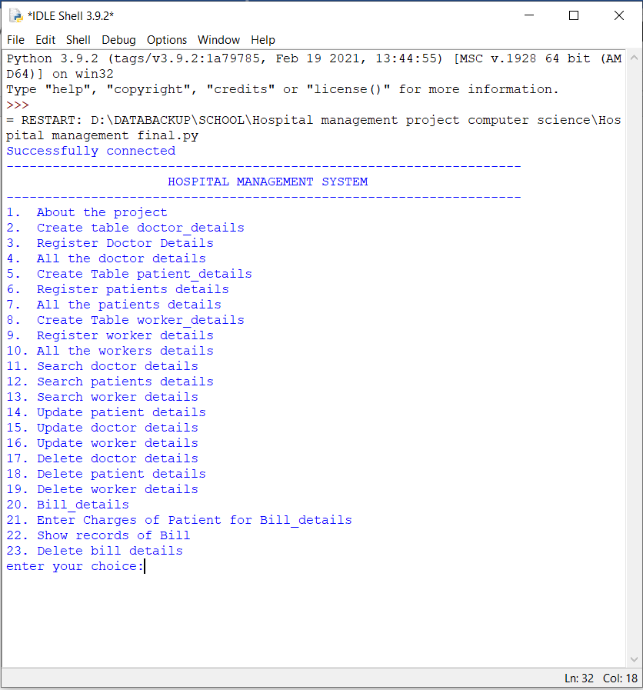

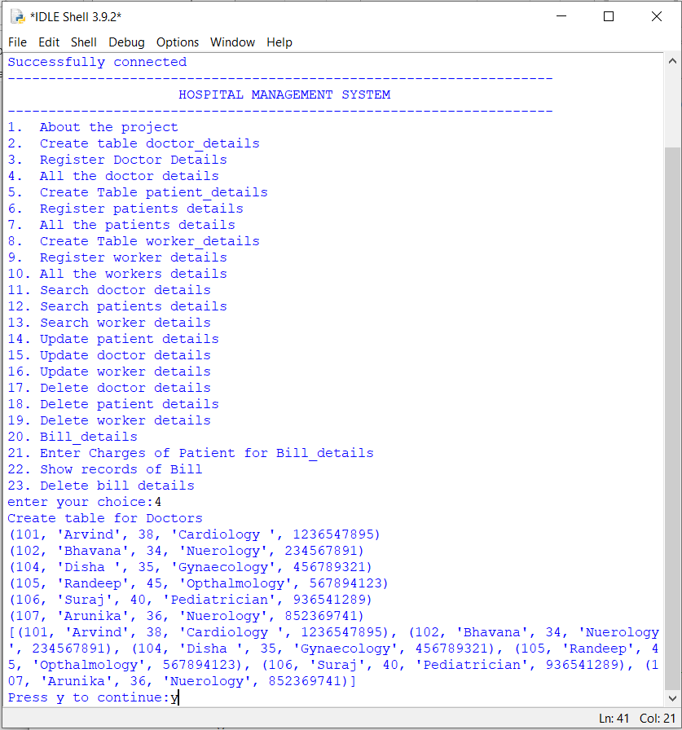

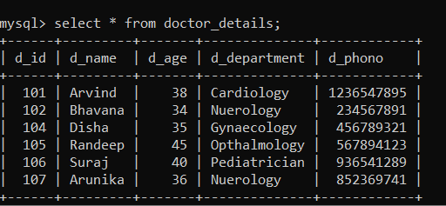

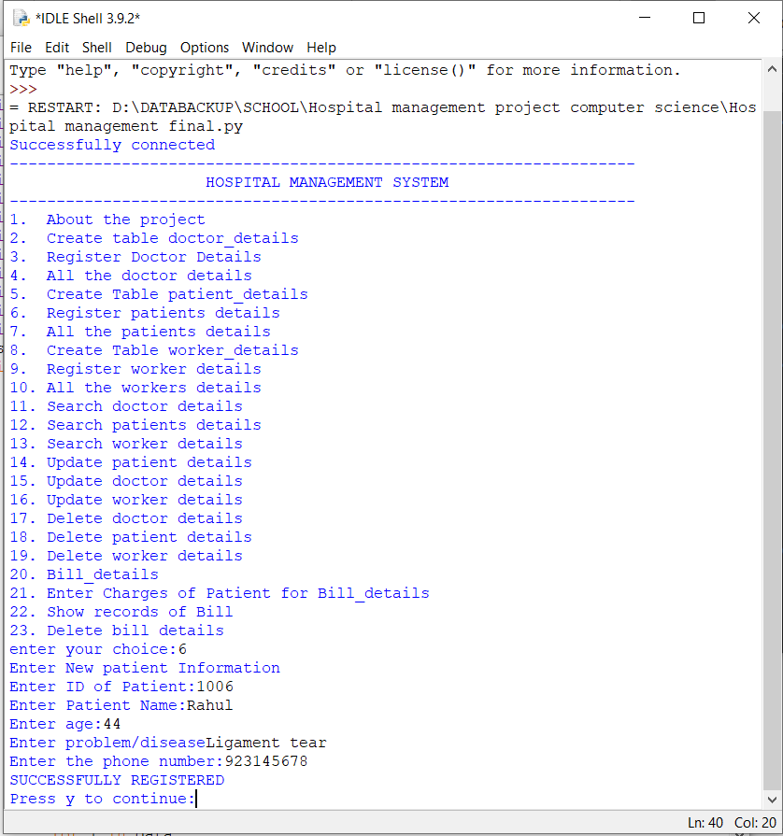

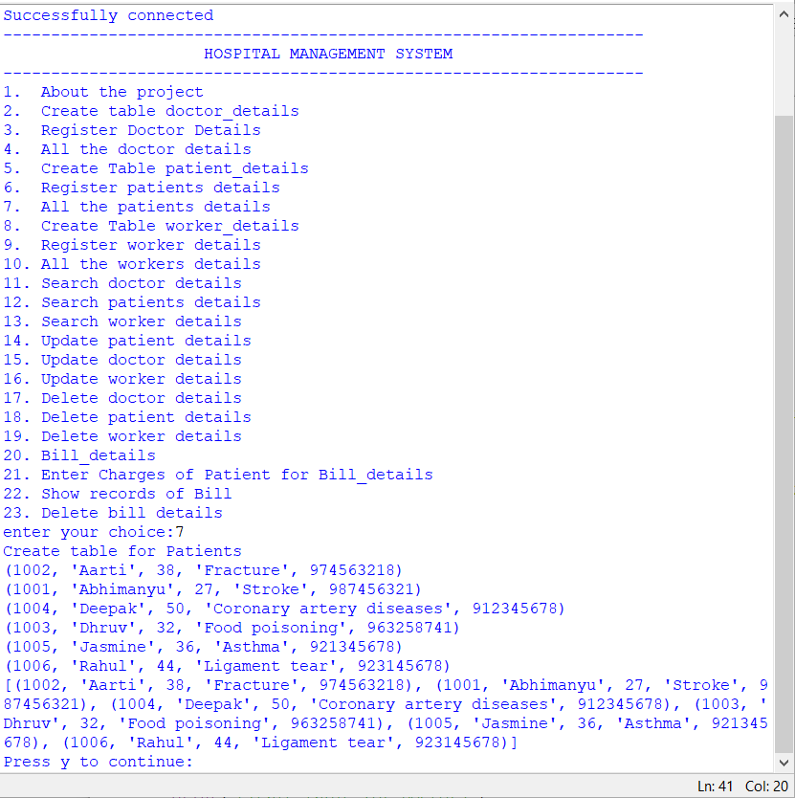

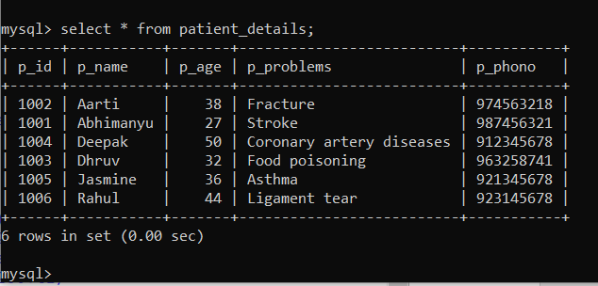

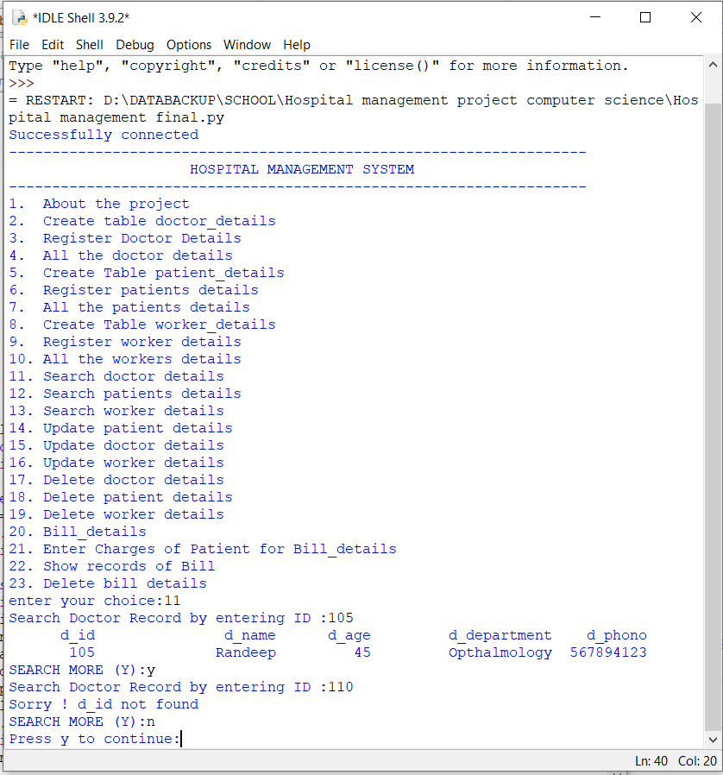

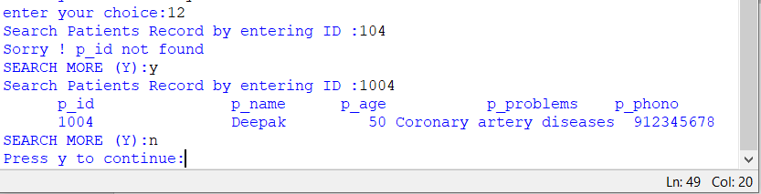

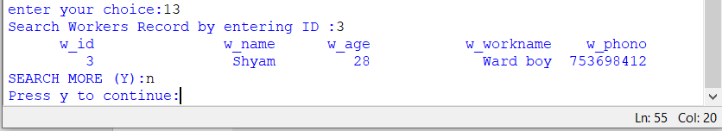

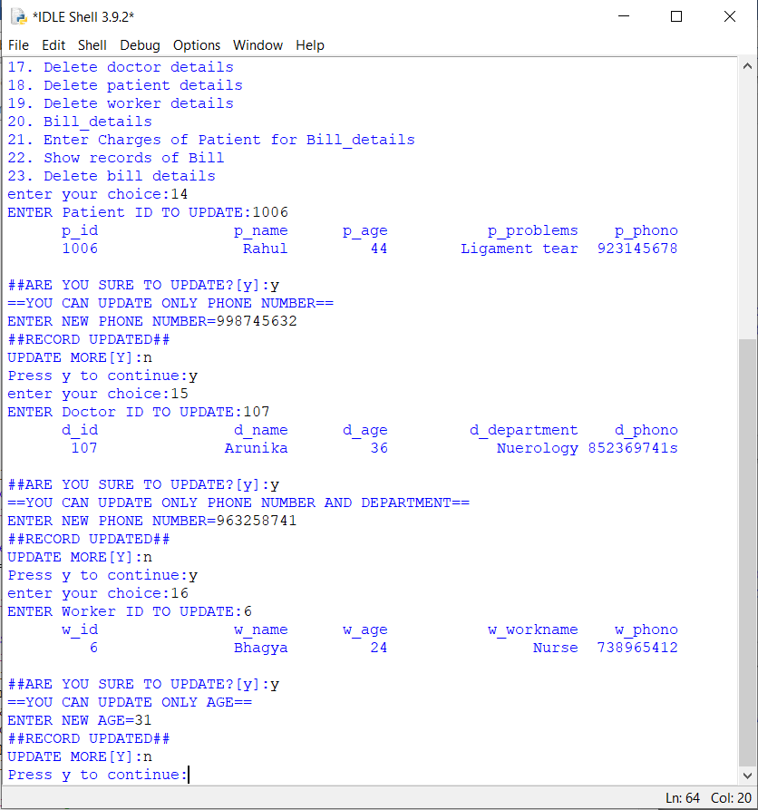

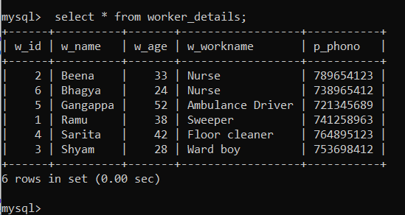

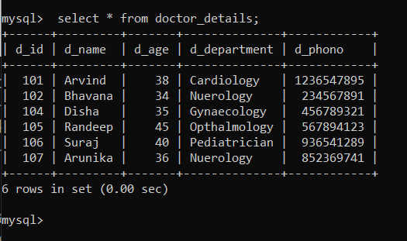

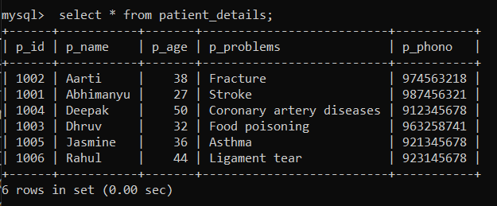

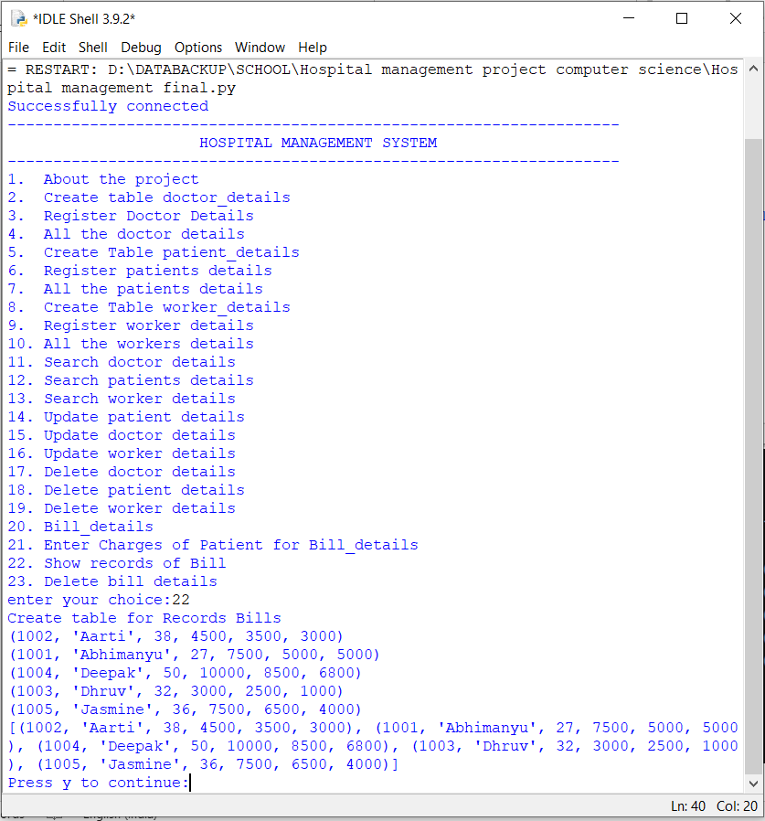

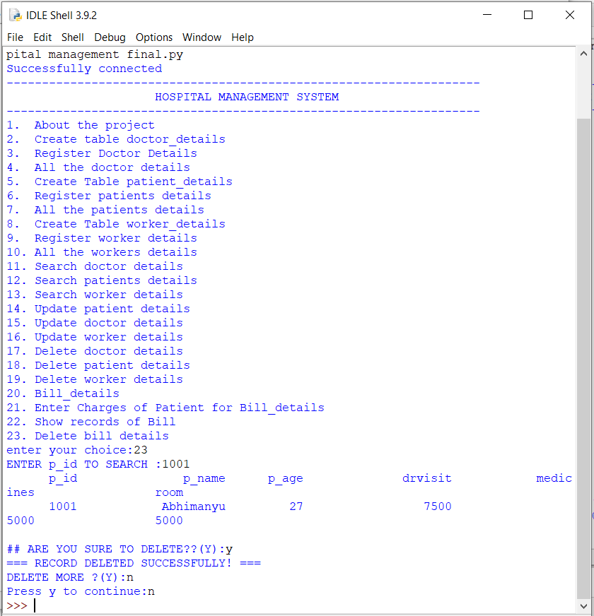

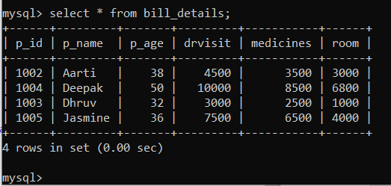

BIBLIOGRAPHY:

* Computer science with Python – class XII By: Sumita Arora
* <https://www.academia.edu>
* <https://www.slideshare.net>